Understanding the Arboretum APIs

The APIs return XML data describing various aspects of the WSU Landscape Arboretum. The APIs were developed using the .NET WebAPIs framework. They are managed via a WSU developed app.

At its most basic level, the APIs expose a list of entities and their attributes. An entity, also known as an object, can be thought of as a thing such as a tree, plant, shrub, rock, theme (aka Tours), etc. Basically, something we want to describe.

When creating an entity, a set of attributes is defined for that entity and then associated with that entity. They are meant to describe the entity.

Examples of attributes for a tree might include, among other things:

* Common Name
* Scientific Name
* Description
* Height
* Minnesota Native

The full list of attributes for a tree can be seen by calling the entity API.

Similarly, examples of attributes for a Theme (aka Tour) include:

* Description
* Color
* Id
* Name

# Accessing APIs

API are accessed via URLs. There are three main URLs available to retrieve information:

### List of themes

[https://w3.winona.edu/locations/api/themes](https://w3.winona.edu/locations/api/themes/%5bthemeID%5d)

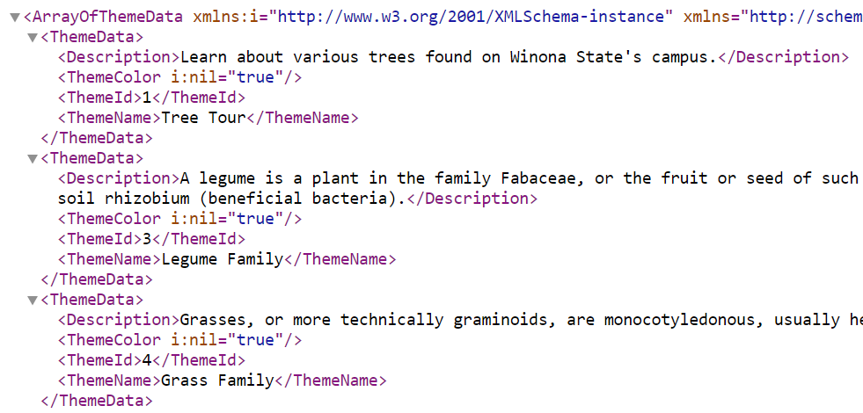

Figure : List of Themes

### Theme

[https://w3.winona.edu/locations/api/themes/[themeID]](https://w3.winona.edu/locations/api/themes/%5bthemeID%5d)

Figure : Theme 1

### Entity

[https://w3.winona.edu/locations/api/entities/[entityID]](https://w3.winona.edu/locations/api/entities/%5bentityID%5d)

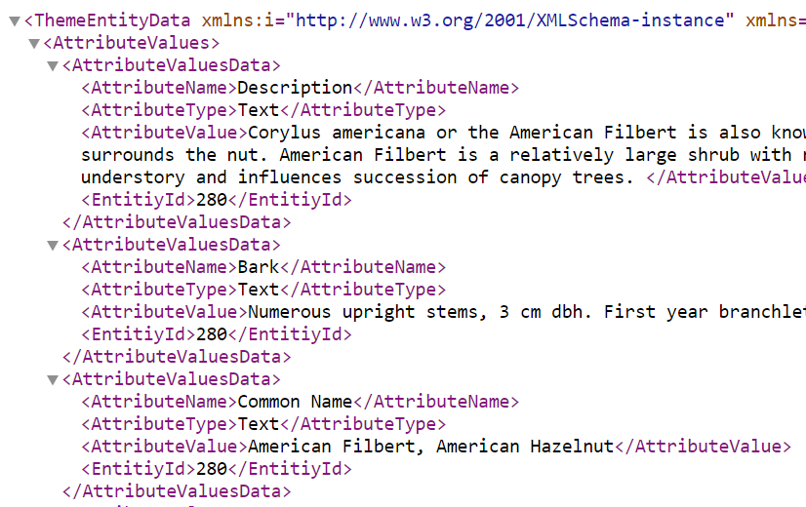

Figure : Entity 280

In addition to attributes, each entity has a set of Locations and Resources associated with that entity.

### Locations

Locations are Lat/Lng data for that entity and an attribute of whether that location is the default location. An example of this would be the Lat/Lng for every instance of Homestead Elm on campus with the specific reference tree marked as *<IsDefaultLocation>true</ IsDefaultLocation>*.

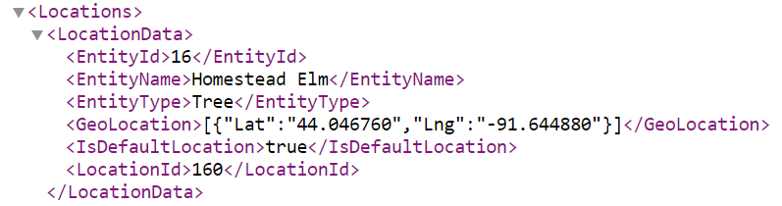

Figure : Location data

### Resources

These attributes denote media-type resources associated with the entity. They can include images, audio, and video.

Figure : Resources data

# FAQ

**Question:** How do I get the tree description via the API for a specific tree?

**Answer**

Entity attributes, such as tree description, can be access via the entities API: [https://w3.winona.edu/locations/api/entities/](https://nam02.safelinks.protection.outlook.com/?url=https%3A%2F%2Fw3.winona.edu%2Flocations%2Fapi%2Fentities%2F&data=04%7C01%7Cjyearous%40winona.edu%7C66dda558ec61485b9d5108da1c3c33c6%7C5011c7c60ab446ab9ef4fae74a921a7f%7C0%7C0%7C637853342137324376%7CUnknown%7CTWFpbGZsb3d8eyJWIjoiMC4wLjAwMDAiLCJQIjoiV2luMzIiLCJBTiI6Ik1haWwiLCJXVCI6Mn0%3D%7C3000&sdata=YtiUOVm2ZAq%2BSQ9j1izeSAPxXXERjVleOFUhjd605o4%3D&reserved=0)[id]

The id for the entity, a tree in this case, can be found by looking at the URL to a specific tree on the site.

For example: American Filbert - <https://www.winona.edu/m/arboretum/about.asp?e=280>

Mouseover/inspect/click the link to American Filbert to get its entity id from the url. 280 is the entity Id for American Filbert. From the XML you can parse out the description.

Figure : American Filbert data

**Question:** How do I get Theme data from the API for a specific theme?

**Answer**

You can find a theme id by going to the web app and viewing the list of pre-defined tours. <https://www2.winona.edu/m/arboretum/default.asp>

**Note:** tour and theme refer to the same thing and are terms used interchangeably.

Select a tour and Mouseover/inspect/click the link for the tour you’re interested in to find the t=[id] value.

Append that value to the theme (tour) url [https://w3.winona.edu/locations/api/themes/[id](https://nam02.safelinks.protection.outlook.com/?url=https%3A%2F%2Fw3.winona.edu%2Flocations%2Fapi%2Fthemes%2F%255bid&data=04%7C01%7Cjyearous%40winona.edu%7C66dda558ec61485b9d5108da1c3c33c6%7C5011c7c60ab446ab9ef4fae74a921a7f%7C0%7C0%7C637853342137480618%7CUnknown%7CTWFpbGZsb3d8eyJWIjoiMC4wLjAwMDAiLCJQIjoiV2luMzIiLCJBTiI6Ik1haWwiLCJXVCI6Mn0%3D%7C3000&sdata=2DH%2BD7AIaKaHzikNNPdplhjZUe65OEUO0UxqRUNwIrg%3D&reserved=0)].

Figure : Tree tour theme